1. **1’S AND 2’S COMPLEMENT:**

**CODE:**

lda 3000

cma

sta 3001

adi 01

sta 3002

hlt

**OUTPUT:**

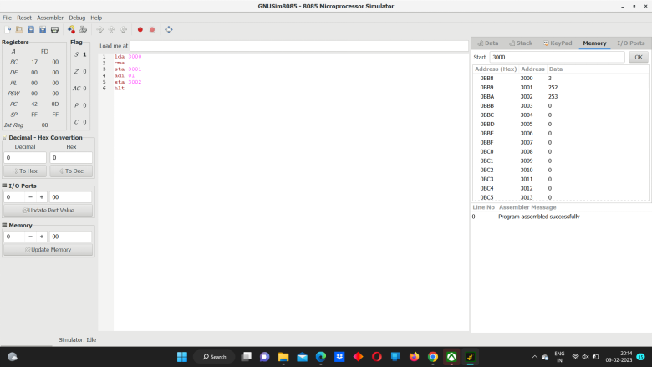sss